Eyeconic - Glasses Shop Management System

Use-Case Specification: Remove Glasses

Version 1.0

Revision History

|  |  |  |  |
| --- | --- | --- | --- |
| **Date** | **Version** | **Description** | **Author** |
| 05/11/2019 | 1.0 | Start creating use case | Đỗ Nguyễn Hoàng Ân |
|  |  |  |  |
|  |  |  |  |
|  |  |  |  |

Table of Contents

1. Remove Glasses 4

1.1 Brief Description 4

2. Flow of Events 4

2.1 Basic Flow 4

2.2 Exception 4

2.2.1 Remove glasses 4

2.2.2 Confirming editing the brand 5

3. Special Requirements 5

4. Preconditions 5

4.1 Admin must be logged in 5

5. Postconditions 5

6. Extension Points 5

Use-Case Specification: Remove Glasses

# Remove Glasses

## Brief Description

This use case defines the step of removing existing glasses from the database.

Glasses are removed by the admin.

# 2. Flow of Events

## 2.1 Basic Flow

The system administratior selects the glasses data to remove. The administrator deletes the glasses data from the website. The system displays the updated management parameter value and logs the change

***Basic flow of Removing Glasses***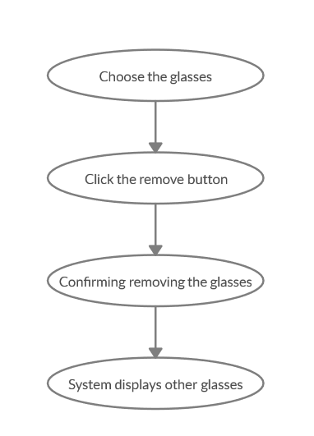

Step 1: Choose the glasses you want to remove

Step 2: Click remove button

A modal view shows up with content “Are you sure want to remove this item?”

and two button “Yes” and “No”

Step 3: Confirming adding the glasses by clicking the “Yes” button.

Step 4: Glasses are removed from database and no longer appeared on the screen.

## 2.2 Exception

### 2.2.1 Remove glasses

The remove button cannot be clicked or isn’t appeared on the screen

### 2.2.2 Confirming editing the brand

The “Yes” button is clicked but the brand are not removed

# 3. Special Requirements

No Special Requirements

# 4. Preconditions

## 4.1 Admin must be logged in

User must already login as the administrator of the website

# 5. Postconditions

All others product can be shown and purchases as normal.

Deleted glasses can not be seen on the screen or database.

# 6. Extension Points

Administrator check the website and the system to ensure that the glasses is completely removed.